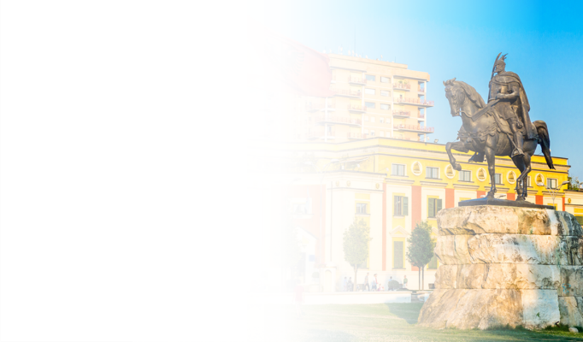
Enhancing the productivity of the public administration
by improving performance management
26 March 2026 | Hotel Rogner, Tirana, Albania
Agenda
 | 09:00 - 09:30 | Welcoming Coffee & Registration
 | 09:30 - 09:50 | Keynote Addresses  - Minister of State for Public Administration and Anti-Corruption, Albania  - Ambassador of the European Union to Albania
 | 09:50 -10:20 | Keynote presentation  - Head of the SIGMA Programme
 | 10:20 -11:30 | Panel 1 - Performance evaluation  - Input by Panel members - Discussion – Conclusions
 | 11:30 -12:00 | Coffee break/networking
 | 12:00 -12:50 | Panel 2 – Financial and other rewards related to performance  - Input by Panel members – Discussion – Conclusions
 | 13:00 -13:50 | Panel 3 - Allocation/delegation of responsibilities as a tool of performance management  - Input by Panel members – Discussion – Conclusions
 | 13:50 -14:00 | Final word
 | 14:00 -15:30 | Buffet Lunch

